ICEP-INTERN

j.mnisi.c.jm@gmail.com

Abstract

This is a report about work we have done so far with the system as developers

SYSTEM REPORT   
FOR   
KASIFOOD-HUB

DEVELOPERS REPORT

# INTRODUCTION

This report has detailed information of the system from Front-End development and Back-End development and showing the connection between the back and front-end development, showing all changes that have occurred from the day that we got the system code to today.

Here is the backlog of the whole system (excludes some items we have not identified any errors on them) to:

1. Update login API
2. Update Database
3. Update product API
4. Update Vendor Registration API
5. Update Customer API
6. Create password Encryption
7. Add driver API for registration and login
8. Create vendor dashboard API
9. Show shops by location API
10. Connect Vendor registration page and Vendor registration API
11. Connect Customer registration page and Customer registration API
12. Connect driver registration page and driver registration API
13. Connect Vendor driver page and Vendor driver API
14. Connect Vendor login page and Vendor login API
15. Connect Customer login page and Customer login API
16. Revamp Vendor Registration page
17. Revamp Customer Registration page
18. Revamp driver Registration page
19. Revamp Vendor login page
20. Revamp Customer login page
21. Revamp driver login page
22. Home page revamp
23. Add code for picture uploading on the product API
24. Added

# BACK-END

We will start with back-end report explaining the changes that have occurred to what is missing and what we have added to the current system.

* We managed to change all registration API’s; they were missing some columns that were crucial for the users of the system

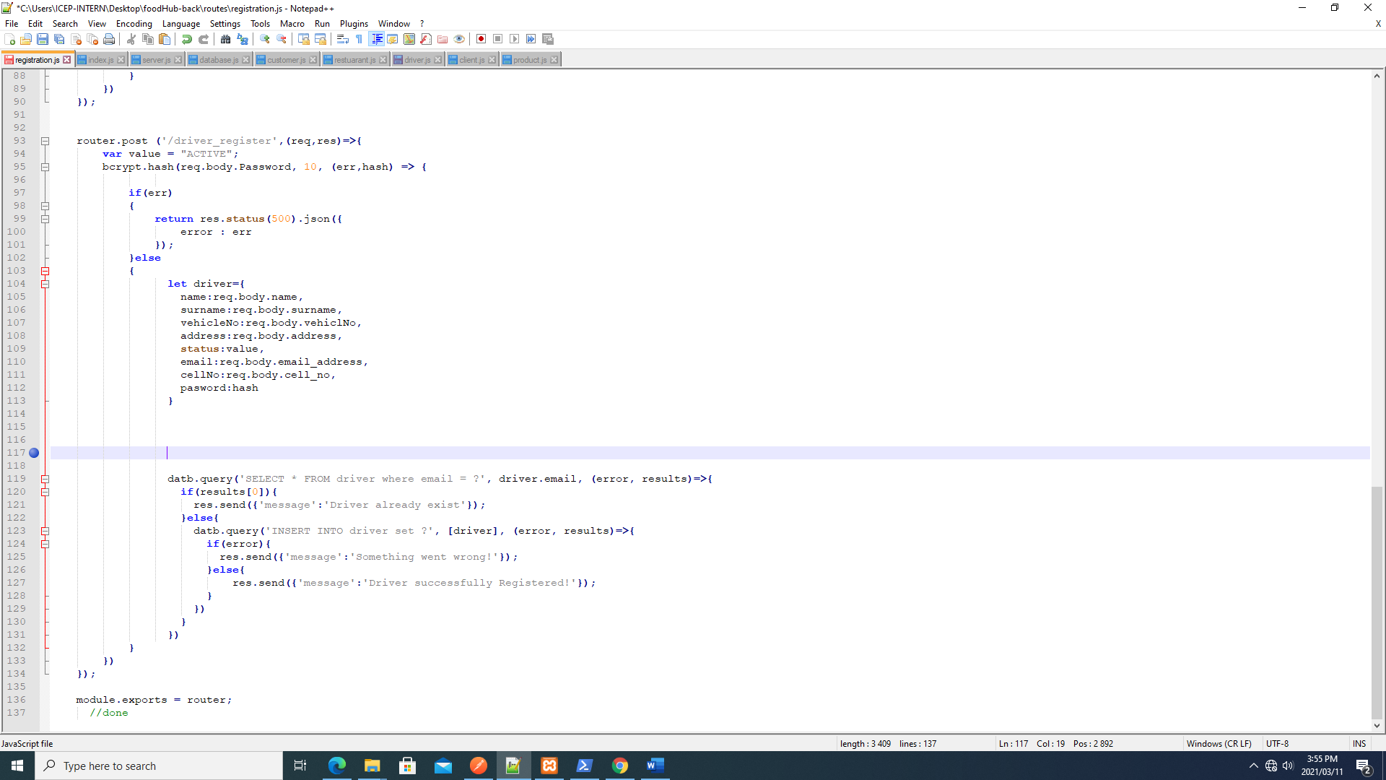

Restaurant registration API

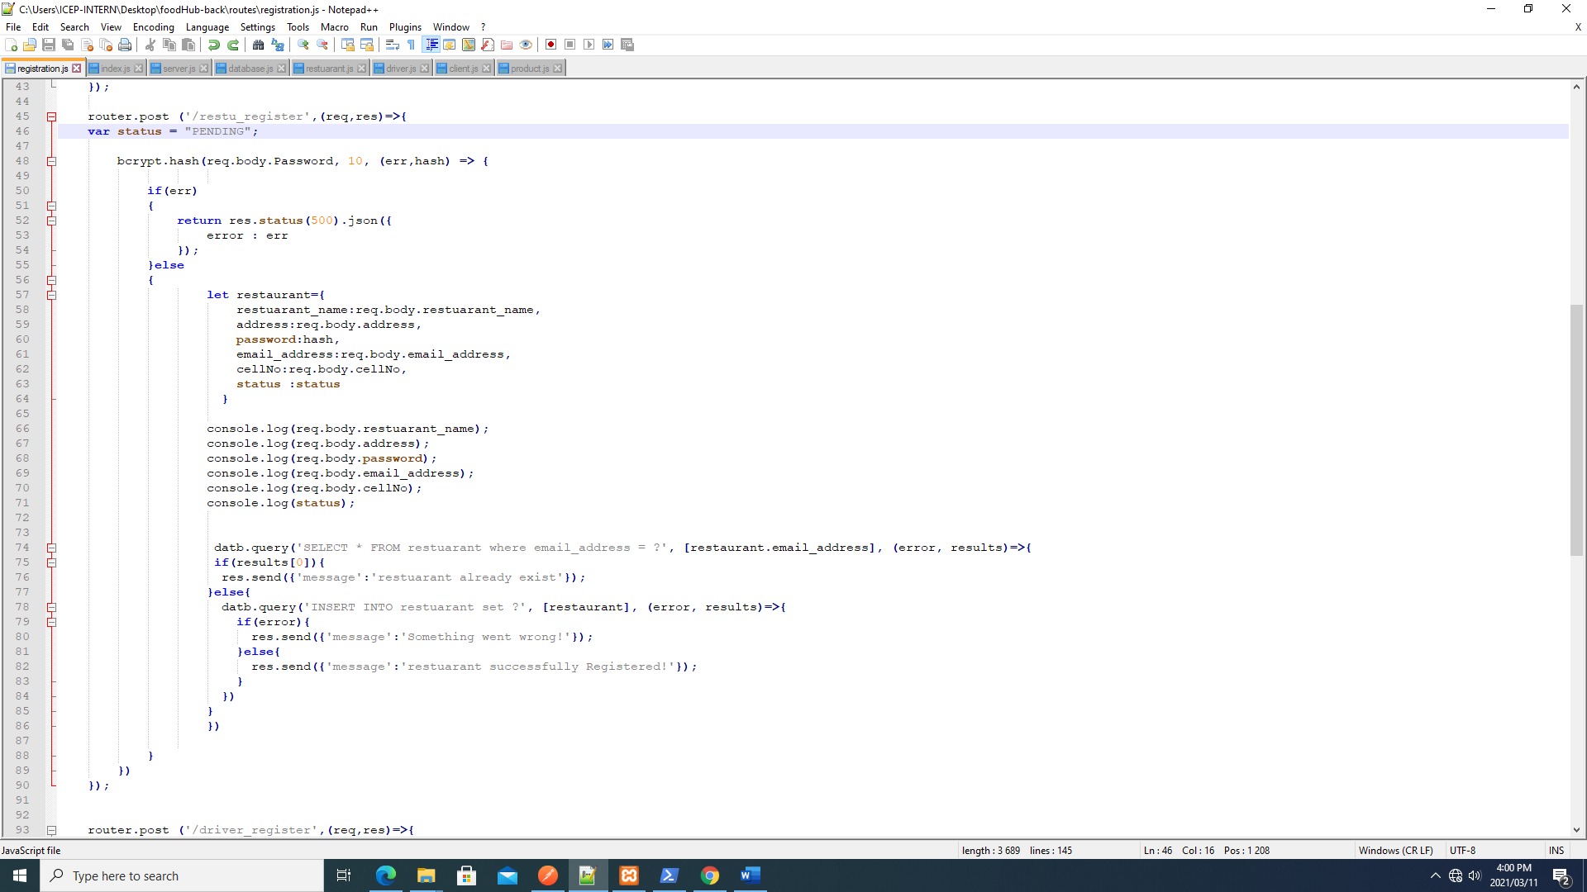

Customer Registration API

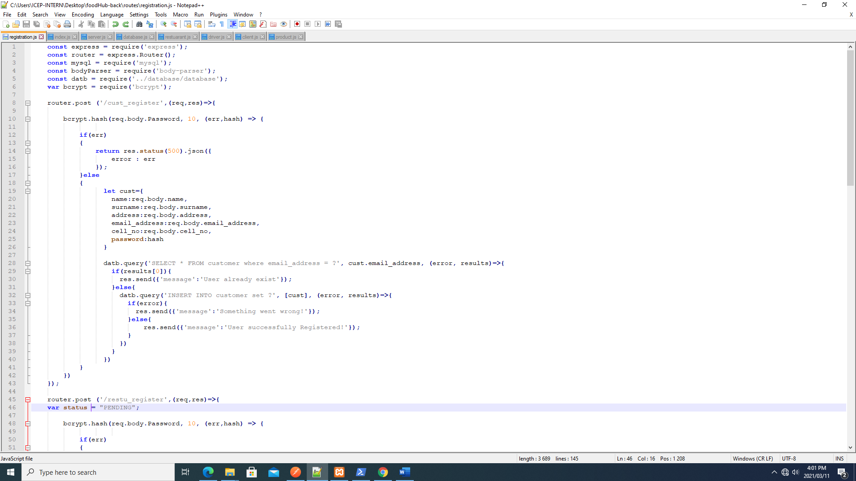

* We managed to create a driver dashboard API to display the menu of the vendor

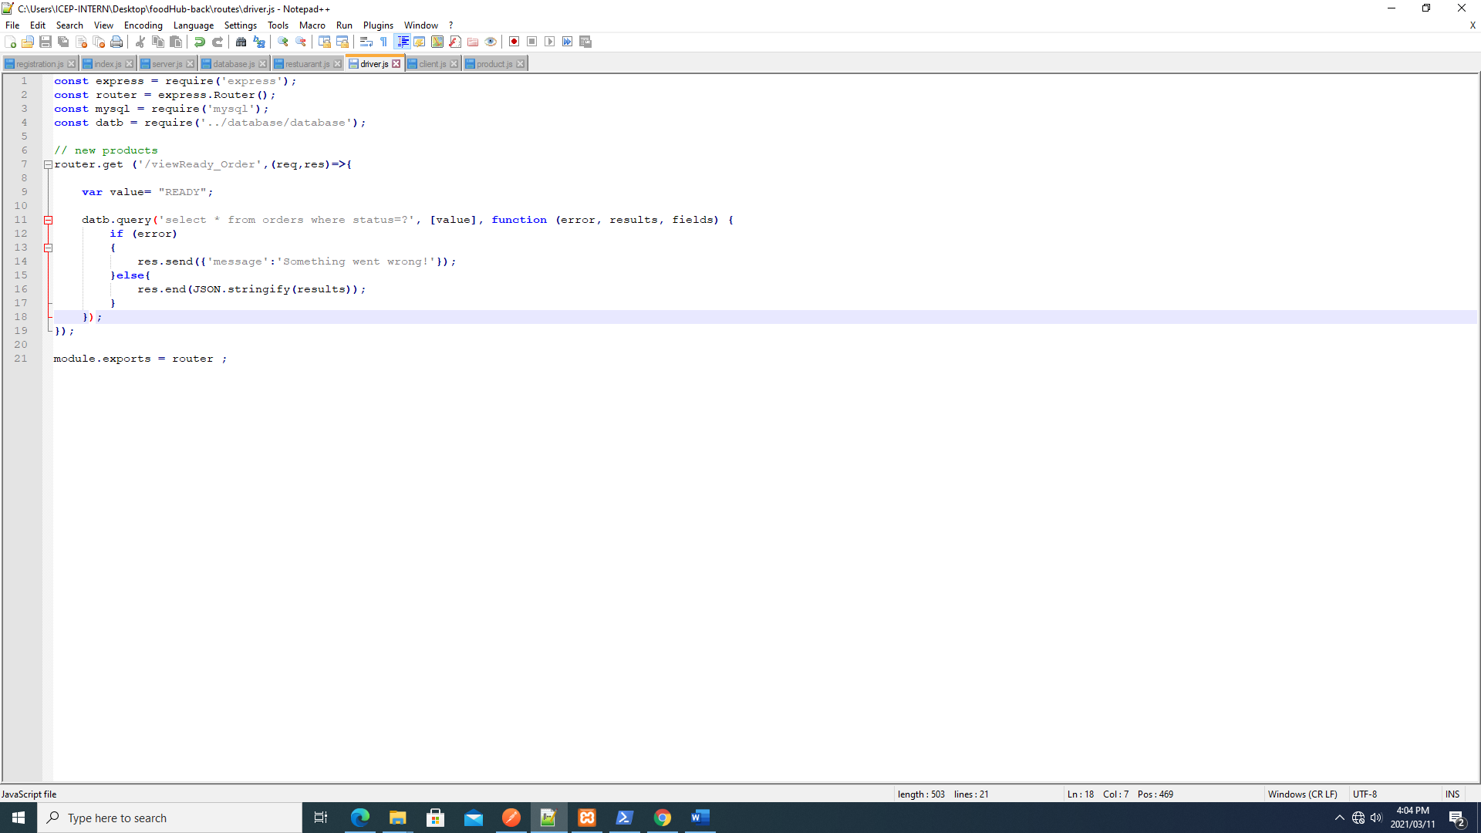

* We Updated the database and added the address table and the logbook table (to keep track of logged in users and store their tokens)

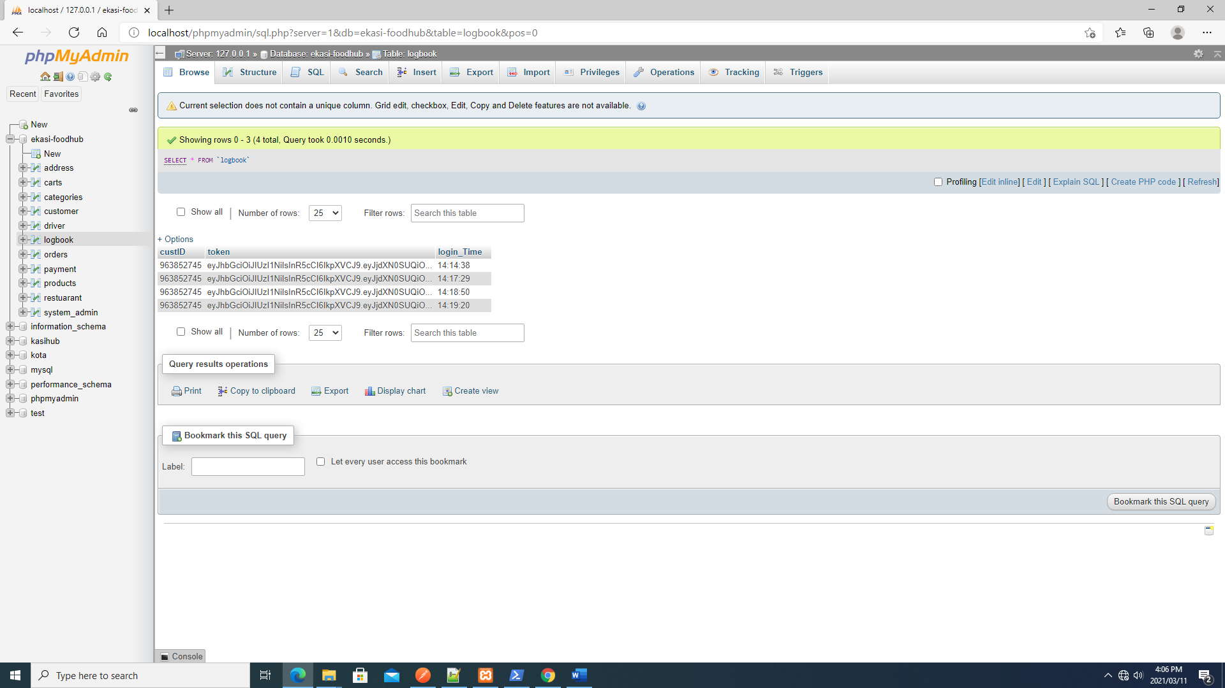

* Updated the search AP from searching using the whole word to searching using key word

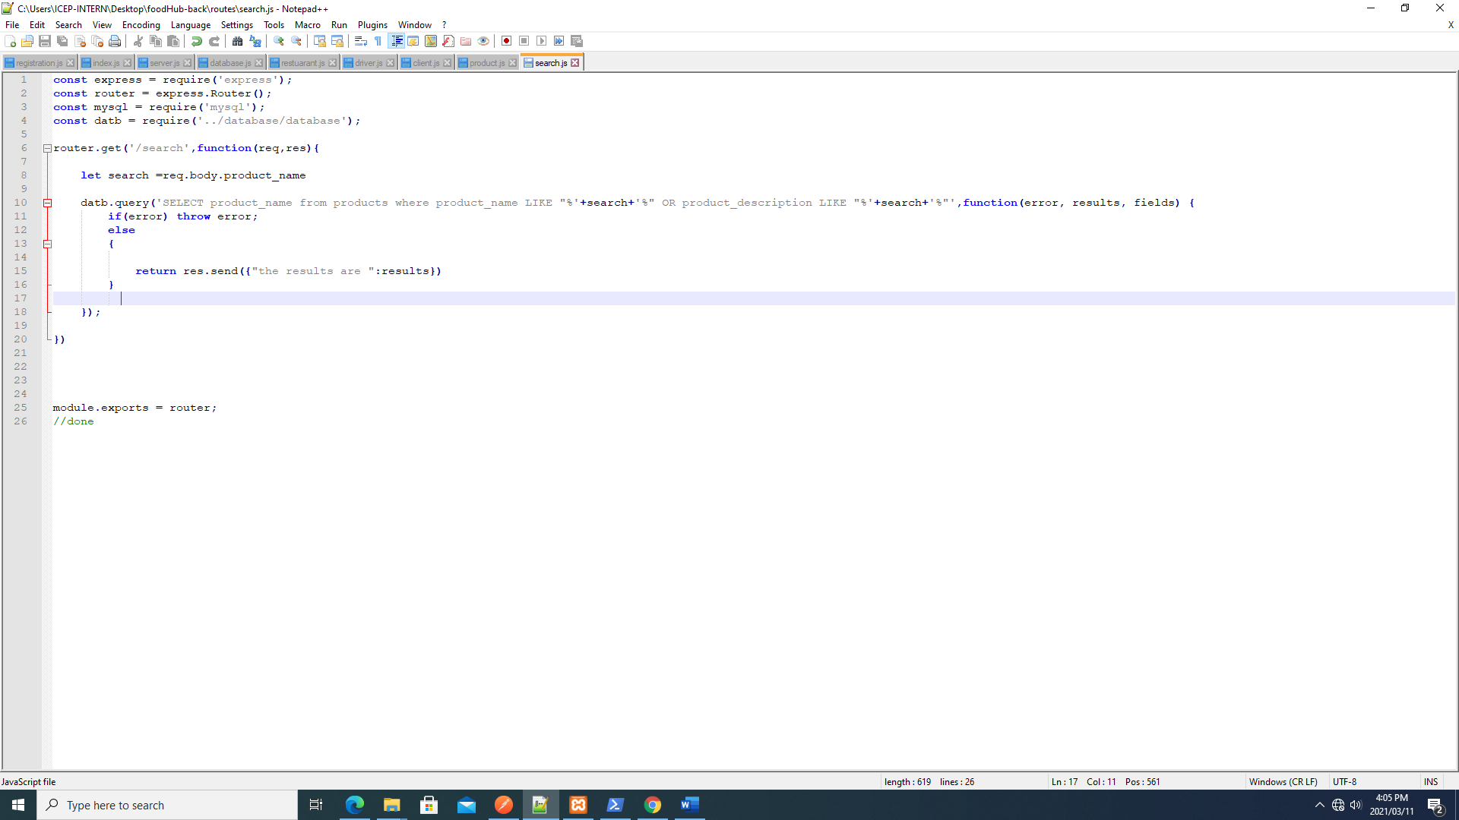

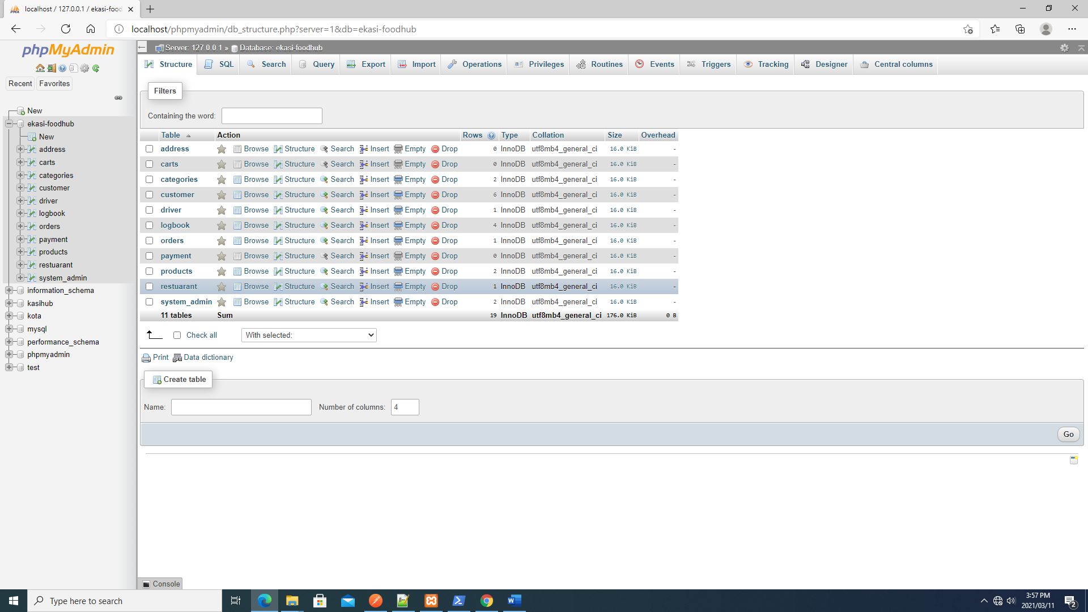

# FRONT END

This is a more detailed report for front end development, from the day we got the project till to date.

* We have done changes on the Customer registration page, what we have removed if the gender

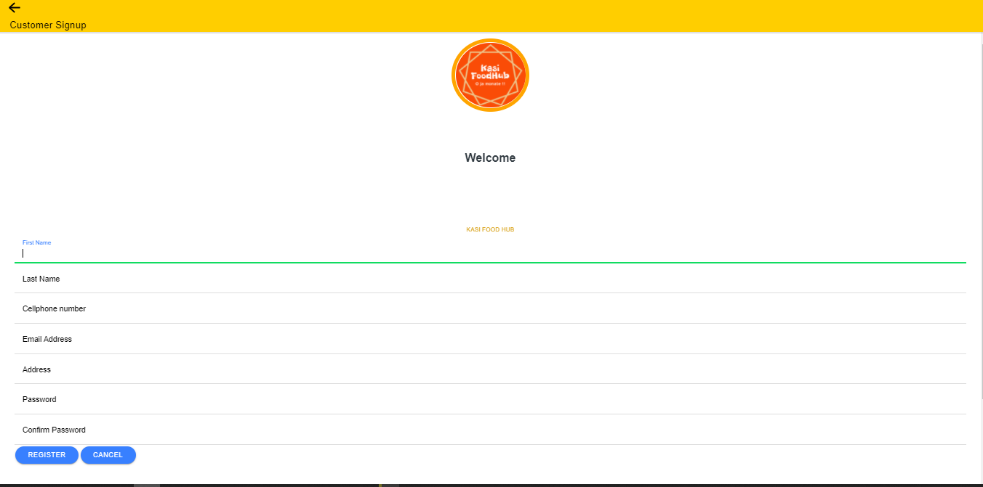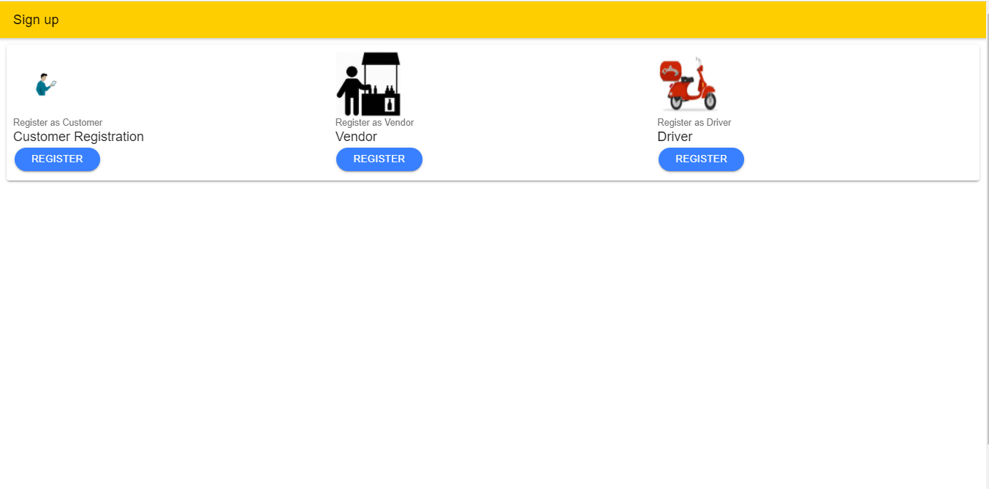

* We currently updating the vendor dashboard
* We are adding validations on registration pages

* Connection the vendor registration with the back end API (we are currently facing challenges on fetching data from the form, but we can connect to the API we use mock data as inputs from the front end)

Mock data

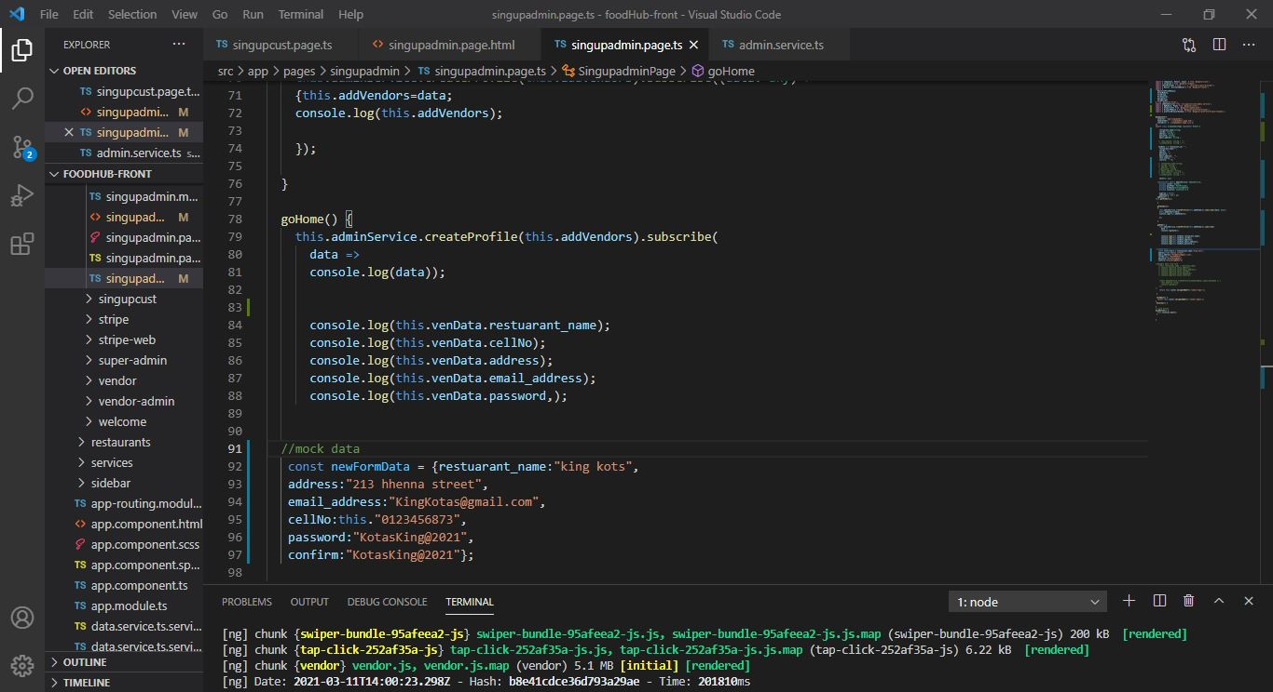

Revamped Vendor registration page with errors we get when we are sending data via the form

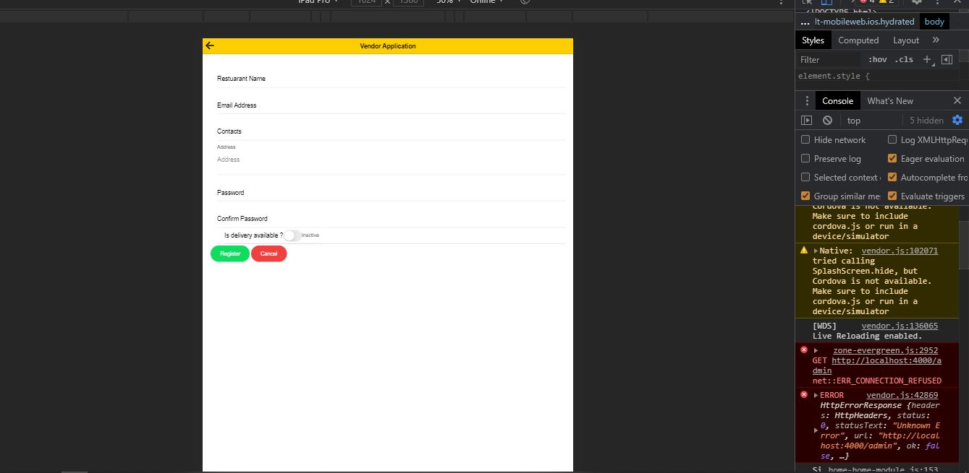

Results we get when we send data using the form

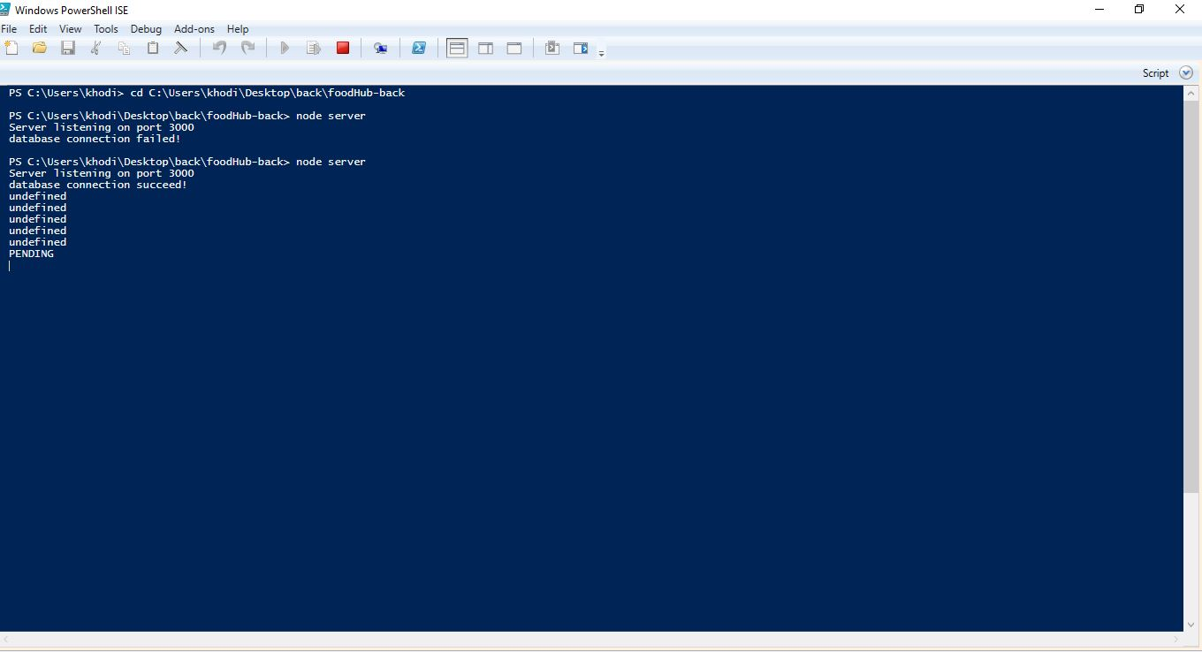

* Updated the menu page so that it displays pictures

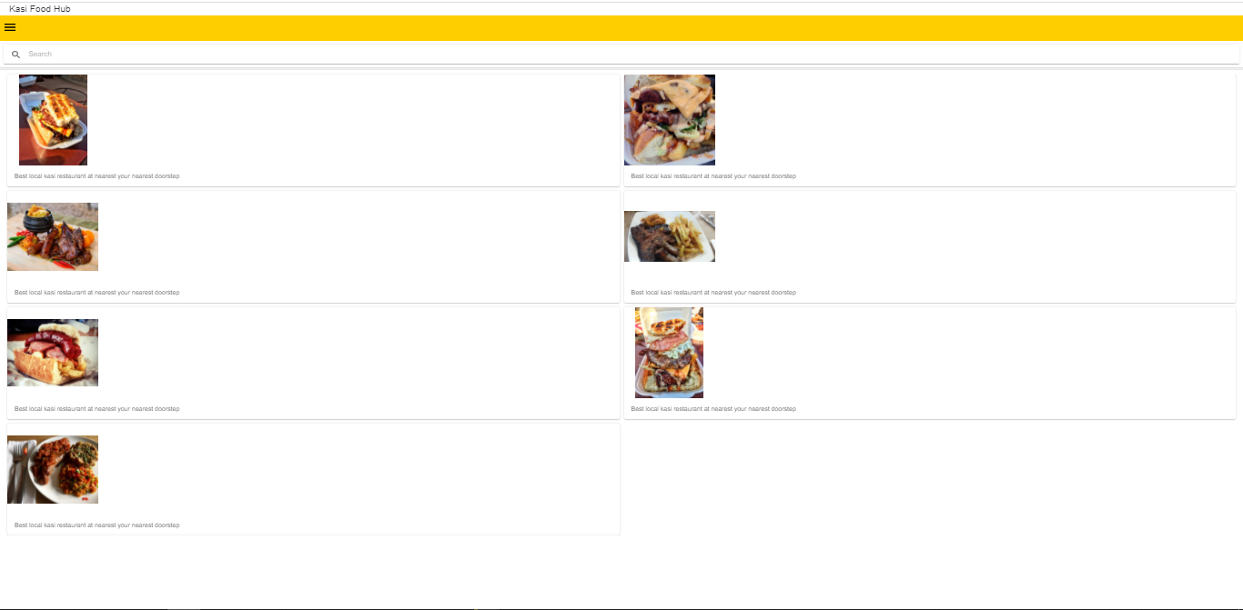

# Conclusion

Taking everything into account, the system is going is approaching a functional state, we are faced with few issues, but we are approaching them with an open mindset, and we will surely overcome them sooner rather than later.